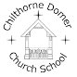 | Willow Class YEAR: 5/6  TERM: Spring
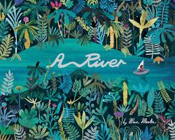  English:  Spring 1:  Poetry: based on The River and I asked the River by Valerie Bloom  Narrative: A River by Marc Martin (settings)  Reports: Mountains | Spring 2:  Poetry: If Rudyard Kipling  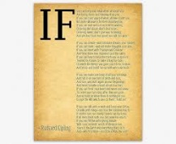  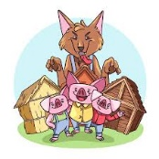  Narrative: The 3 Little Pigs (from a different point of view)  Discussion: were the 3 Little Pigs really innocent? |  |   Geography:  North Somerset Coast and Severn estuary  Europe: Danube River  North America: Rocky Mountains
  PSHE:  Safety and the changing body | MATHS:  Year 5:  arithmetic  fractions  multiplication and division  decimals and percentages  perimeter and area |   Year 6:  Fractions  Measure- converting units  Ratio  Algebra  Decimals  Area and perimeter
PHYSICAL EDUCATION:  Cognitive: Real P.E Unit 3  Creative: Real P.E Unit 4 | TOPIC/THEME:  Explore |  | DT:  Come dine with me  Doodler/Steady hand game
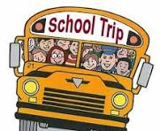
Trips and experiences:
Trip linked to Geography focus- TBC
COMPUTING:  Active Bytes  Handling Data: Spreadsheets  Multimedia: My Weather Forecast  Programming: Microbit Unit Getting Active | SCIENCE:  Year 5  Animals including humans  Properties and changes in materials |   Year 6:  Animals including humans  Evolution and Inheritance | RELIGIOUS EDUCATION:  Understanding Christianity: Gospel  AMV Unit- What do Christians believe about Salvation?
CHRISTIAN VALUES:  Courage and Forgiveness | HOMEWORK:  Weekly: Doodle Maths 3x a week or more.  Daily: reading (5 signatures required per week)  SAT’S practise- year 6 only

