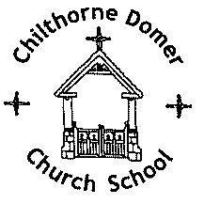
CHILTHORNE DOMER CHURCH SCHOOL
Main Street
Chilthorne Domer
Yeovil
Somerset BA22 8RD
Headteacher: Mrs N Chesterton
TEL & FAX.: 01935 840407
E-MAIL: office@cdcs.uk
WEBSITE: www.chilthornedomerchurchschool.co.uk

June 2023
Information from our Digital Leaders

Dear Marsh Lane,

I am a Digital Leader from Chilthorne Domer Church School and I help Mrs Stradling to lead Online Safety across the school and within our local community.

I would like to share our Building Habits poster with you. We use these in school to help our children make positive choices when using devices. In addition to their use in school, we also send this home to support our families and are now reaching out to our community to make others aware. We have included the EYFS poster for your use in nursery and will explain some of the habits below.

You need to ASK. You need to ask before you do things on your own. an adult before using a device.

You need to SHARE what you are doing online with those around you, especially adults.

You need to TELL an adult if you see something that makes you upset.

You need to BE KIND to people online and in real life.

You need to MOVE to keep your body active.

You need to CHECK if an adult can see you.

You need to think about the amount of TIME that you are using a device.

Finally, you need to make sure you complete a MIX of activities that balance out your time on a device e.g. playing in the garden, going for a walk or reading a story.

Thank you for reading. I hope that you will find the Building Habits poster helpful.

Yours sincerely,

Ruby

Digital Leader

