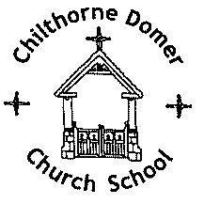
CHILTHORNE DOMER CHURCH SCHOOL
Main Street
Chilthorne Domer
Yeovil
Somerset BA22 8RD
Headteacher: Mrs N Chesterton
TEL & FAX.: 01935 840407
E-MAIL: office@cdcs.uk
WEBSITE: www.chilthornedomerchurchschool.co.uk

June 2023
Information from our Digital Leaders

Dear Forget Me Not Pre-School,

I am a Digital Leader from Chilthorne Domer Church School and I help Mrs Stradling to lead Online Safety across the school and within our local community.

I help the children to be safe online at school and I am writing to tell you about the Building Habits posters that we use to help our children make positive choices when using devices. In addition to their use in school, we also send this home to support our families and are now reaching out to our community to make others aware. We have included the EYFS poster for your use in nursery and will explain some of the habits below.

ASK an adult before using a device.

TELL an adult what you are doing especially if you see a pop up.

BE KIND to people online and in real life.

MOVE to keep your body active.

CHECK Can your adult see what you are doing?

Think about the amount of TIME that you are using a device and lastly make sure you complete a MIX of activities that balance out your time on a device e.g. playing in the garden, going for a walk or reading a story.

Thank you for listening. I hope that you will find the Building Habits poster helpful.

Yours sincerely,

Isaac

Digital Leader

